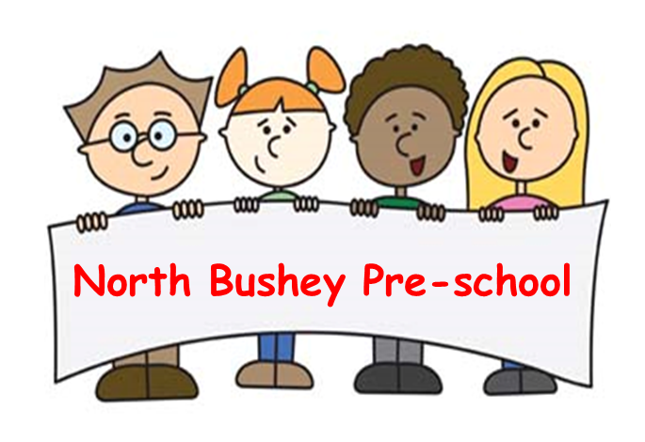
06 Safeguarding children, young people and vulnerable
adults procedures
06.08 Looked after children
Identification.
A 'Looked after Child' is a child in public care, who is placed with foster carers, in a residential home or with parents/carers or other relatives.
Services provided to Looked After Children
Two-year-olds
- Places will be offered to two-year-old children who are looked after, subject to availability and in accordance with local authority funding arrangements.
- Where the child is already in attendance and has a secure attachment with an existing key person, continuity of care and placement will be supported wherever possible.
Three- and four-year-olds
- Places will be offered for funded three- and four-year -olds who are looked after; subject to availability and in accordance with local authority funding arrangements.
- If a child who attends the setting becomes looked after and is placed with local carers, every effort will be made to maintain continuity of placement where appropriate.
Additional Support
- The designated safeguarding lead and key person at North Bushey Preschool liaise with agencies and professionals involved with the child, and his or her family, and ensure appropriate information is gained and shared.
- A meeting of professionals involved with the child is convened by the setting at the start of a placement. A Personal Education Plan (PEP) for children over 3 years old is put in place within 10 days of the child becoming looked after.
- Following this meeting, 06.08a Care plan for looked after children form is completed. The care plan is reviewed after two weeks, six weeks, three months, and thereafter at three to six monthly intervals.
- North Bushey Preschool will maintain regular contact with the child’s social worker and other relevant professionals through planned meetings, which will include contribution to the PEP which is reviewed annually.

