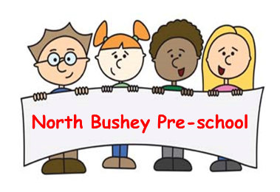
04. Health procedures
04.06 Oral health
North Bushey Preschool provides care for children and promotes health through promoting oral health and hygiene, encouraging healthy eating, healthy snacks and tooth brushing.
- Fresh drinking water is always available and easily accessible.
- Sugary drinks are not served.
- In partnership with parents/carers, babies are introduced to an open free-flowing cup at 6 months and from 12 months are discouraged from using a bottle.
- Only water and milk are served with morning and afternoon snacks.
- Children are offered healthy nutritious snacks with no added sugar.
- Parents/carers are discouraged from sending in confectionary as a snack or treat.
- Staff follow the Infant & Toddler Forum’s Ten Steps for Healthy Toddlers.
Where children clean their teeth when at the setting
- Children are encouraged to brush their teeth as part of their daily home hygiene routine. We will support awareness of that teeth should not be cleaned for at least one hour after a meal as this can cause loss of enamel.
- Parents/carers are offered the opportunity to provide a toothbrush, toothpaste and a cup for each individual child.
- Each child’s toothbrush, paste and cup are stored individually to prevent cross contamination.
- Toothbrushes are cleaned at each session and sterilised weekly in Milton or similar disinfecting fluid
- Toothbrushes are changed every three months and provided by parents/carers.
- Oral hygiene activities are included in planning at least every three months when toothbrushes are changed.
- The setting co-ordinates with local oral health and ensure procedures are reviewed regularly, additional guidance from the local team may be added to this procedure.
Pacifiers/dummies
- Parents are encouraged to stop using dummies/pacifiers once their child is 12 months old.
- We do not allow the use of dummies/pacifiers whilst at Preschool due to hygiene concerns and because it helps children develop their language and communication skills.
Further guidance
Infant & Toddler Forum: Ten Steps for Healthy Toddlers www.infantandtoddlerforum.org/toddlers-to-preschool/healthy-eating/ten-steps-for-healthy-toddlers/

