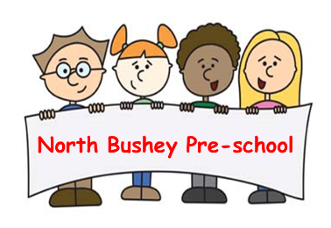

03 Food safety and nutrition procedures
03.03 Menu planning and nutrition
Food provides a healthy, balanced diet for growth and development. Foods that contain any of 14 allergens identified by the FSA are identified on menus. Dietary guidance to promote health and reduce risk of disease is followed. When planning menus, the setting manager and staff ensure that:
- Parents/carers and staff are able to contribute ideas for snack menus.
- Menus reflect cultural backgrounds, religious restrictions and food preferences of some ethnic groups.
- Daily Snack Menus are clearly displayed so that parents and staff know what is being provided.
- Foods that contain any of the 14 major allergens are identified on the menu that is displayed for parents/carers.
- Parents/carers must share information about their children’s particular dietary needs with staff when they enrol their children and on an on-going basis with their key person.
- Key persons regularly share information about the children’s levels of appetite and enjoyment of food with parents/carers.
- Staff refer to Help for early years providers : Food safety which includes:
Example menus for early years settings in England: Guidance and Example menus for early years settings in England : Recipes
- Eat Better, Start Better - Foundation Years.
- The staff use the visual allergy record displayed of children’s dietary needs for Food Allergy and dietary preferences and requirements.

Packed lunches
Where children have packed lunches, staff promote healthy eating, ensuring that parents/carers are given advice and information about what is appropriate content for a child’s lunch box. Parents/carers are also advised to take measures to ensure children’s lunch box contents remain cool i.e. ice packs, as the setting does not have facilities for refrigerated storage.

