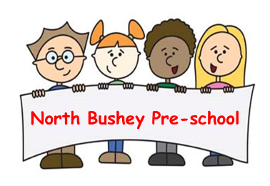

01 Health and safety procedures
01.09 Laundry
- Children do not have access to laundry towel bin.
- Laundry is washed and dried off site. (Towels, Aprons, dressing up, etc)
- Biological detergents are not used due to the risk of allergies.
- If children’s clothes are soiled, we tip solids in the toilet. They are then bagged immediately and sent home.
- Members of staff wash their hands after handling dirty laundry.

